**East West University**

**Lab Report**

**Semester:** Summer-2024

**Course Title:** Electrical Circuits **Course Code:** CSE209

**Sec:** 01

**Expt No: 04**

**Expt Name:** To analyze the Bias Point Detail of the DC circuit with a dependent source using PSpice Schematics.

**Group No: 07**

**Submitted by-**

Name: Sheikh Sarafat Hossain

Id: 2022-3-60-109

**Submitted to-**

Dr. Sarwar Jahan

Associate Professor

Department of Computer Science & Engineering

East West University

**Date of Performance: 14-July-2024**

**Date of Submission: 28-July-2024**

**Objective:**

1. To analyze the Bias Point Detail of the DC circuit with a dependent source using PSpice Schematics.

**Theory:**

A dependent source consists of two elements: the controlling and controlled elements.

The controlling element is either a voltage or a current and the controlled element is either a voltage or a current. Four types of dependent sources correspond to the four ways of choosing a controlling element and a controlled element. These four dependent sources are

Voltage-controlled voltage source (VCVS)

Voltage-controlled current source (VCCS)

Current-controlled voltage source (CCVS)

Current-controlled current source (CCCS)

The dependent sources can be found in the parts list in PSpice Schematics. Click on the get parts list. The letter E represents VCVS, VCCS is represented by the letter G, CCVS is represented by the letter H and CCCS is represented by the letter F in PSpice. These parts have the shapes

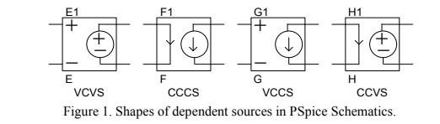

Using VCVS dependent source we got:

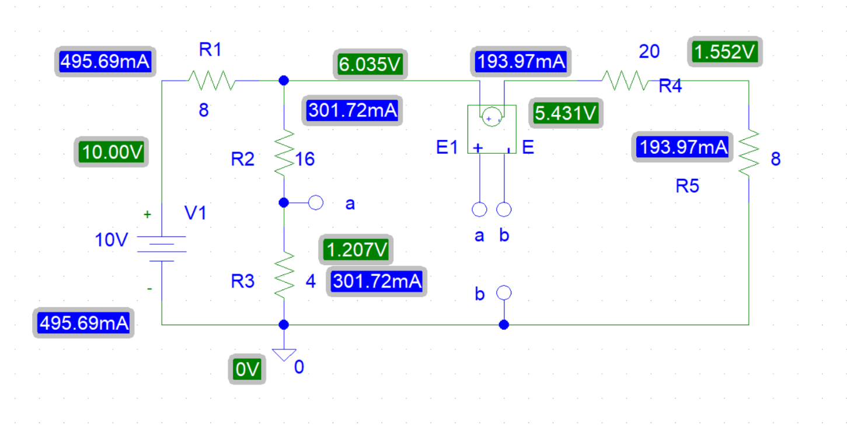

Using VCCS dependent source we got:

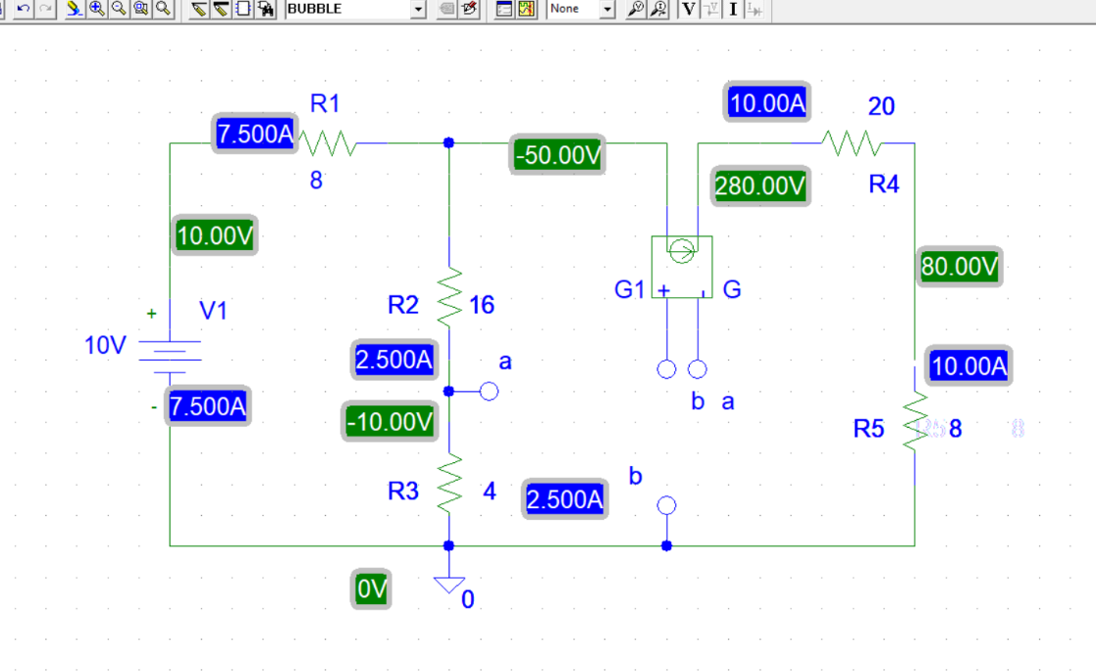

Using CCVS dependent source we got:

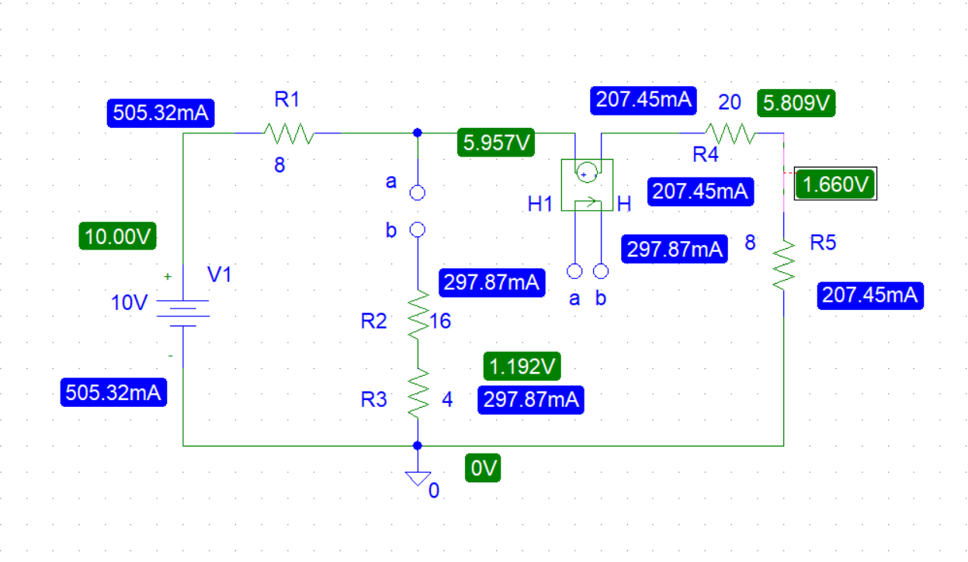

Using CCCS dependent source we got:

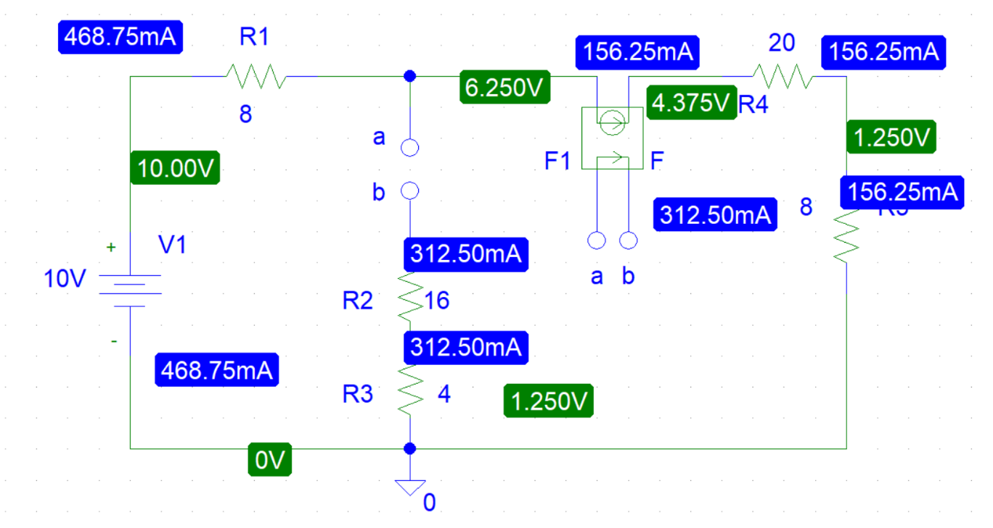

**Lab practice problem:**

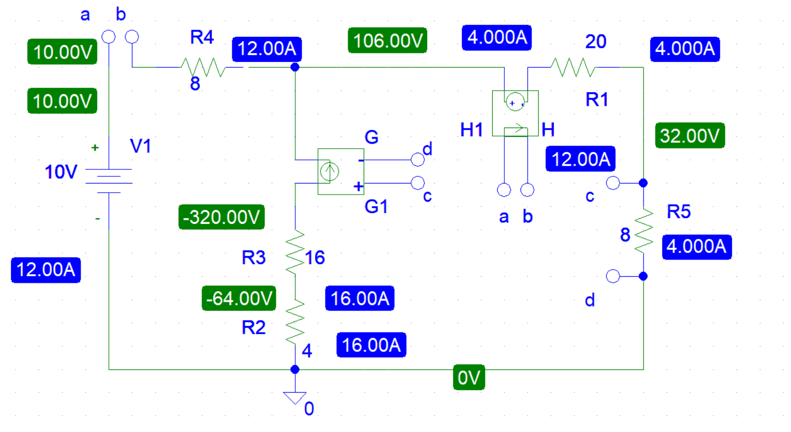

**Post Lab Report Question:**

**1.** Theoretically calculate all the currents and the voltages for the circuit shown in Figure 11. Compare the theoretical solution of the circuit shown in Figure 11 with the solutions obtained from the PSpice simulation.

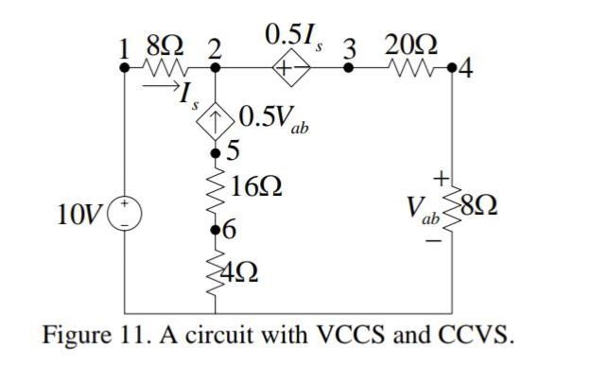

**Ans:**

Here we can say,

**Is = I1**

**Vab= 8I2**

Applying KCL at node 2,

I2 – I1 = 0.5 Vab

Or, I2 – I1 = 0.5 * 8I2

Or, I2– I1 = 4I2

Or, I1 – 3I2 = 0

Applying KVL at the super mesh,

-10 + 8 I1 + 0.5 Is + 20 I2 + 8 I2 = 0

Or, -10 + 8 I1 + 0.5 I1 + 20 I2 + 8 I2 = 0

8.5 I1 + 28 I2 = 10 ……(2)

Solving equation (1) and (2) we get,

**I1 = -12A**

**I2 = 4A**

Let’s assume,

0.5 Vab =Id,

So, we can write, Id = I2– I1

= 4-(-12)

**Id = 16A**

Now, Voltage at Node 1,

**V1 = 10V**

Applying KCL at node2,

**V2=106V**

Voltage at Node 3, V3=4× 28

|  |  |
| --- | --- |
| **V3 =112V**  Voltage at Node 4,  V4 = 4 × 8 | [[ I2=4A and R = (20+8) Ω ] |
| **V4 = 32V**  Voltage at Node 5, V5= - (16 × 20) | [ I2= 4A and R = 8 Ω ] |
| **V5 = - 320V**  Voltage at Node 6,  V6 = - (16 × 4) | [ Id = 16A and R = (16 + 4) Ω ] |
| **V6 = - 64V** | [ Id = 16A and R = 4 Ω ] |
|  |  |

**2.** Compare the theoretical solution of the circuit shown in Figure 11 with the solutions obtained from PSpice simulation.

**Comparing all the values:**

|  |  |  |
| --- | --- | --- |
|  | Pspice | Theoretical |
| Current | I1= 12A | I1= -12A |
| I2= 4A | I2= 4A |
| Id= 16A | Id= 16A |
| Voltage | V1 = 10V | V1 = 10V |
| V2 = 106V | V2 = 106V |
| V3 = 112V | V3 = 112V |
| V4= 32V | V4= 32V |
| V5 = -320V | V5 = -320V |
| V6 = -64V | V6 = -64V |

